# CS 255 System Design Document – Elliot Putnam

This template lays out all the different sections that you need to complete for Project Two. Each section has guidance to prompt your thinking. You will need to continually reference the interview transcript as you work to make sure that you are addressing your client’s needs. There is no required length for the final document. Instead the goal is to complete each section based on what your client’s needs are. Remove this note when you are finished, and replace all bracketed text with the relevant information.

## UML Diagrams

### UML Use Case Diagram

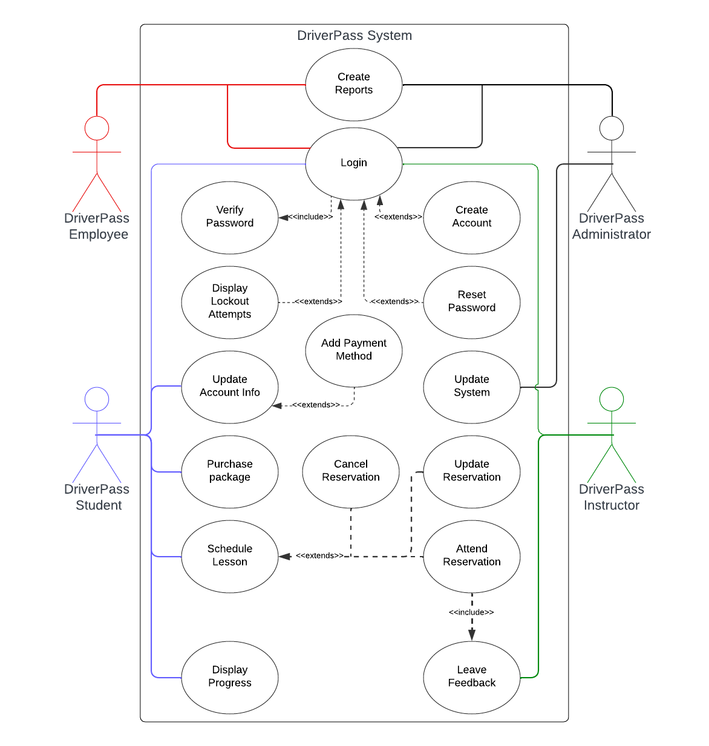

### UML Activity Diagrams

*[You were asked to choose* ***two*** *use cases and create* ***two*** *activity diagrams, one for each use case. Please insert* ***both*** *of your activity diagrams here. Check to make sure that you included appropriate components and symbols and that your design meets the client’s needs.]*

### UML Sequence Diagram

### UML Class Diagram

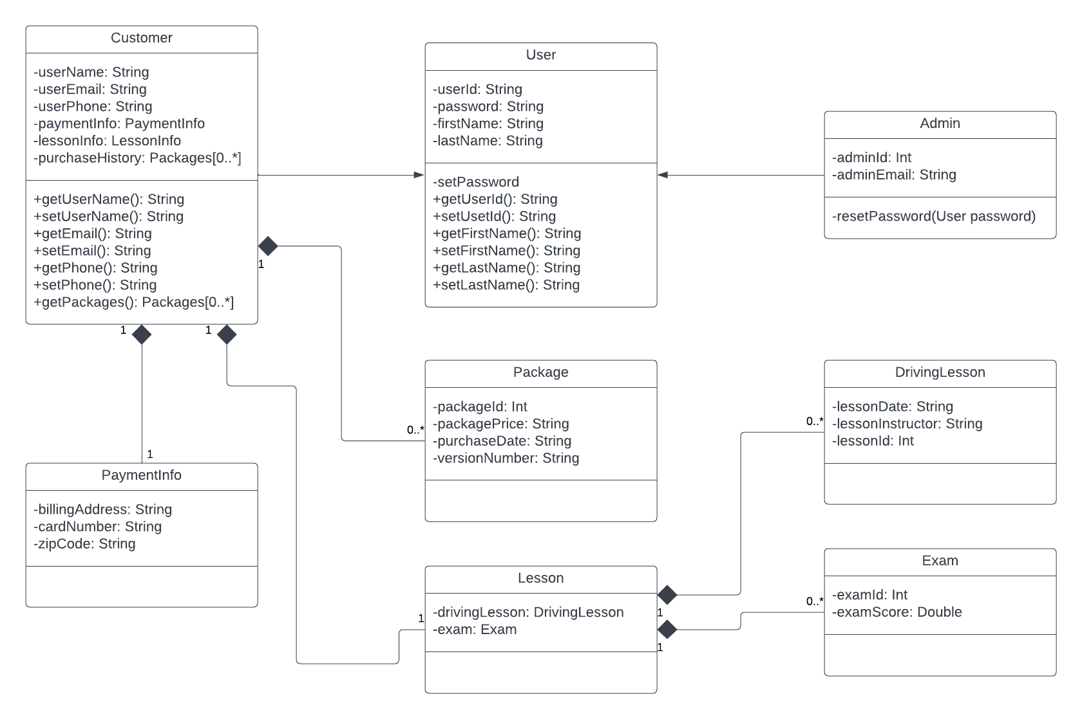

## Technical Requirements

1. Required Hardware
   1. Client device
   2. Server computer
   3. Devices and peripherals for employees
   4. Vehicles
2. Software
   1. Web-based platform
   2. Client to server encryption
   3. Class specific methods
   4. Browser access (chrome, firefox, edge, safari)
3. Tools
   1. Lucid diagramming
   2. IDEs and frameworks for efficient development
   3. Version control system